**Vision College Student Portal**



By Nash Smith

2018

**Client Details** **4**

**Project Scope** **4**

Website Purpose 4

Target Audience 4

Organisation Goals 4

Features 4

**Visual Planning** **5**

Colour Palette 5

Fonts 5

Headings 5

Content 5

Page Planning 6

Landing Page 6

Assignment Page 6

Student Bio Page 6

Module Page 6

Student Projects Page 6

Interactive Marking Rubric 6

**Task Time List** **7**

Pricing 7

**Page Layouts** **8**

Landing Page 8

Assignments 9

Student Bio 10

Module 11

Student Projects 12

Interactive Marking Rubric 13

Side Navigation 14

Student Home 15

**Final Design** **16**

**Browser Compatibility** **17**

**Sitemap** **18**

Student 18

# Client Details

**Name**: Jacqualine East

**Company Name**: ATC Vision College

**Contact Number**: 027 777 888

**Email**: [jacqualine.east@visioncollege.ac.nz](mailto:jacqualine.east@visioncollege.ac.nz)

# Project Scope

## Website Purpose

The purpose of this website is to provide Students, Tutors and Potential Employers with a platform that will assist with finding course information, submitting coursework, marking coursework and finding capable students for employment.

## Target Audience

The target audience for this website is ATC Vision College students and tutors and also community members looking to employ a student.

## Organisation Goals

The goal of this website is to help courses run smoothly by having an efficient and easy to use student portal. Coursework and grades will be clearer and more available, which can help students stay inspired. Another goal is to match employers up with students to create more job opportunities for students.

## Features

* Multiple Account Privilege Levels.
* Secure Pages.
* Assignment Submissions and Grading.
* Student Information Requests.
* Interactive Marking Rubric.
* Show/Hide Side Navigation.

# Visual Planning

## Colour Palette

This colour palette consists of the two Vision College blues and includes an in between blue for hierarchy with the extremes, white and black for contrast.

|  |  |  |  |  |
| --- | --- | --- | --- | --- |
| **#000000** | **#002C5A** | **#00458D** | **#0094C4** | **#FFFFFF** |

## 

## Fonts

### Headings

Gilroy Ultra Bold

font-family: Gilroy-ExtraBold, Arial, Helvetica, sans-serif;



### Content

Open Sans Condensed



## Page Planning

### Landing Page

**Purpose:** Logging in and creating accounts.

**Content:** Log in form. Create account form.

### Assignment Page

**Purpose:** Supply all information about each assignment.

**Content:** Information about the assignment. Links to results. Links to download assignment documents. Link to submit an assignment.

### Student Bio Page

**Purpose:** Supply information about a student, mainly for a potential employer.

**Content:** Student basic information, skills, projects, work experience. Request a students mobile or email. Shows if the student is accepting work or not.

### Module Page

**Purpose:** Show all information about a specific module.

**Content:** Module information. Which assignments the module includes.

### Student Projects Page

**Purpose:** Showcase student work to potential employers.

**Content:** Thumbnails of each project along with a link to the live websites and names of who worked on the project.

### Interactive Marking Rubric

**Purpose:** An easy way for tutors to mark assignments. Point and click on a score in the rubric, the calculations are done for them.

**Content:** Interactive rubric and other tables to show totals and grades.

# Task Time List

|  |  |  |  |  |  |
| --- | --- | --- | --- | --- | --- |
|  | Weeks | | | |  |
| Tasks | 1 | 2 | 3 | 4 | Hours |
| Initial Documentation |  |  |  |  | 15 |
| Client Approval of Proposal |  |  |  |  | 1 |
| Database Creation |  |  |  |  | 3 |
| Create Templates |  |  |  |  | 2 |
| Navigation/Headers |  |  |  |  | 4 |
| Student Pages |  |  |  |  | 30 |
| Tutor Pages |  |  |  |  | 30 |
| Community Pages |  |  |  |  | 10 |
| Client Meeting to Check Progress |  |  |  |  | 2 |
| Testing |  |  |  |  | 10 |
| Make Changes |  |  |  |  | 5 |
| Migrate to Host |  |  |  |  | 1 |
| Final Test |  |  |  |  | 5 |
| Site Complete |  |  |  |  | 118 |

## Pricing

**Hourly Price:** $40

**Total Time:** 118 hours

**Total Price:** $40 * 118 hours = $4720

This website is part of an assignment, therefore there will be no billing or payments taking place.

# Page Layouts

## Landing Page

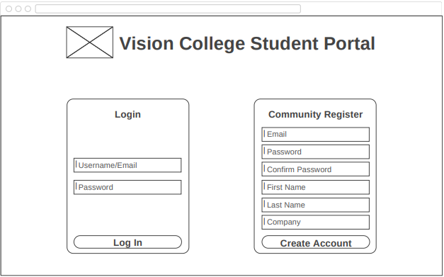

## Assignments

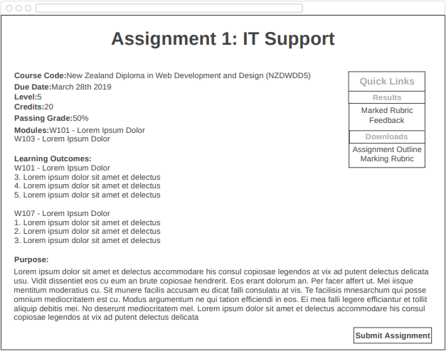

## Student Bio

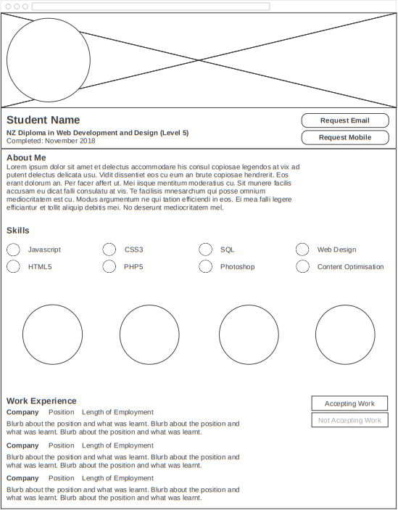

## Module

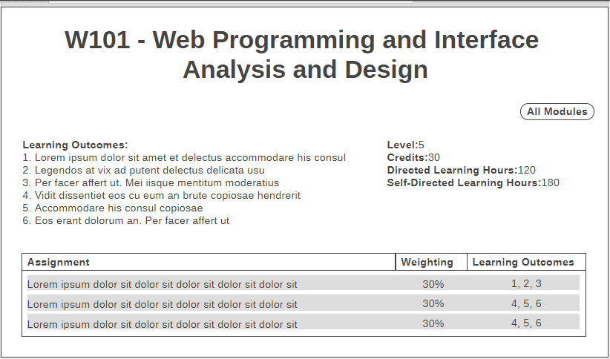

## Student Projects

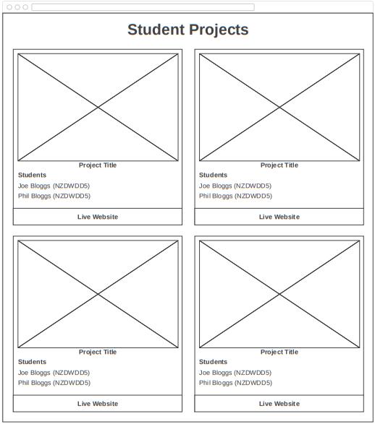

## Interactive Marking Rubric

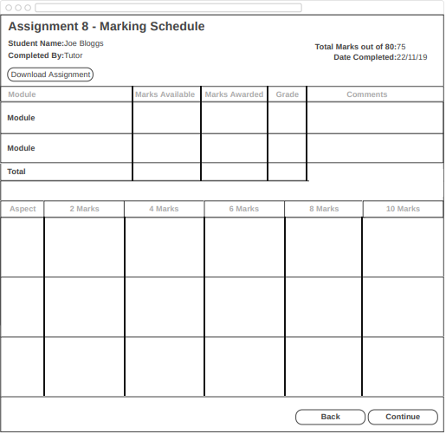

## Side Navigation

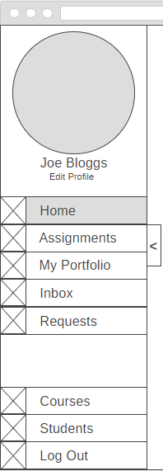

## Student Home

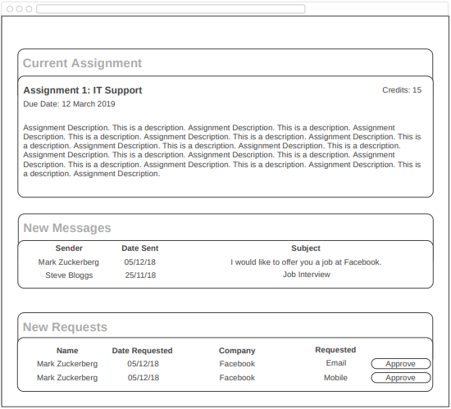

# 

# Final Design

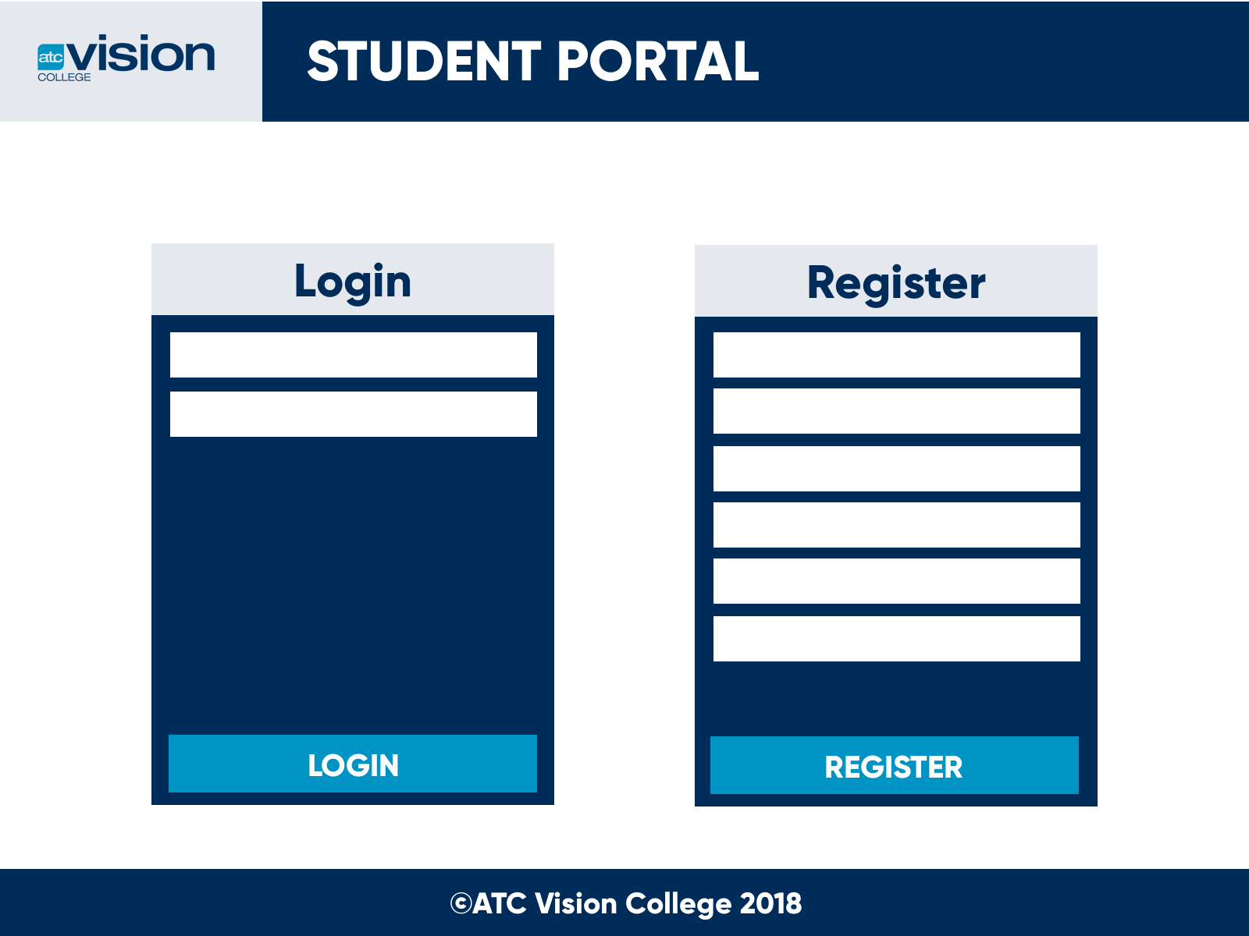

# Browser Compatibility

|  |  |  |  |  |
| --- | --- | --- | --- | --- |
| **Google Chrome** | **Firefox** | **Safari** | **Opera** | **Internet Edge** |
| Versions  58 - Current | Versions  53 - Current | Versions  10.1 - Current | Versions  45 - Current | Limited  17+ |

# Sitemap

## Student

